**Department of Computer Science and Engineering**

|  |  |
| --- | --- |
| **Course Code: CSE370** | **Credits: 1.5** |
| **Course Name: Database Systems** | **Semester: Summer’19** |

**Lab 01  
Part-A  
Setting Up and Connecting to the MySQL Server**

1. **Topic Overview:**

This is a short introduction to Database Systems. Brief overview of the expectations and outcomes of the lab i.e. informing students about the project they have to submit at the end of the semester are discussed. After that the students will install and connect to the MySQL server.

1. **Lesson Fit:**

There is no pre-requisite to this lab as this is an introductory lab.

1. **Learning Outcome:**

After this lecture, the students will be able to:

* 1. Install MySQL Server
  2. Connect to the server
  3. Login and create a database to write sample queries.

1. **Anticipated Challenges and Possible Solutions**
   1. Students might face problem copying the installation directory to their computers.

**Solutions:**

* + 1. Faculty will install a copy in the Projector PC to show them the procedure.

1. **Acceptance and Evaluation**

This is a preliminary setup. Students won’t be evaluated for this task.

**Activity List for Part A**

**Step 1: Go to TSR> (current semester)> CSE> NNC(Najeefa)>CSE370(Lab)**

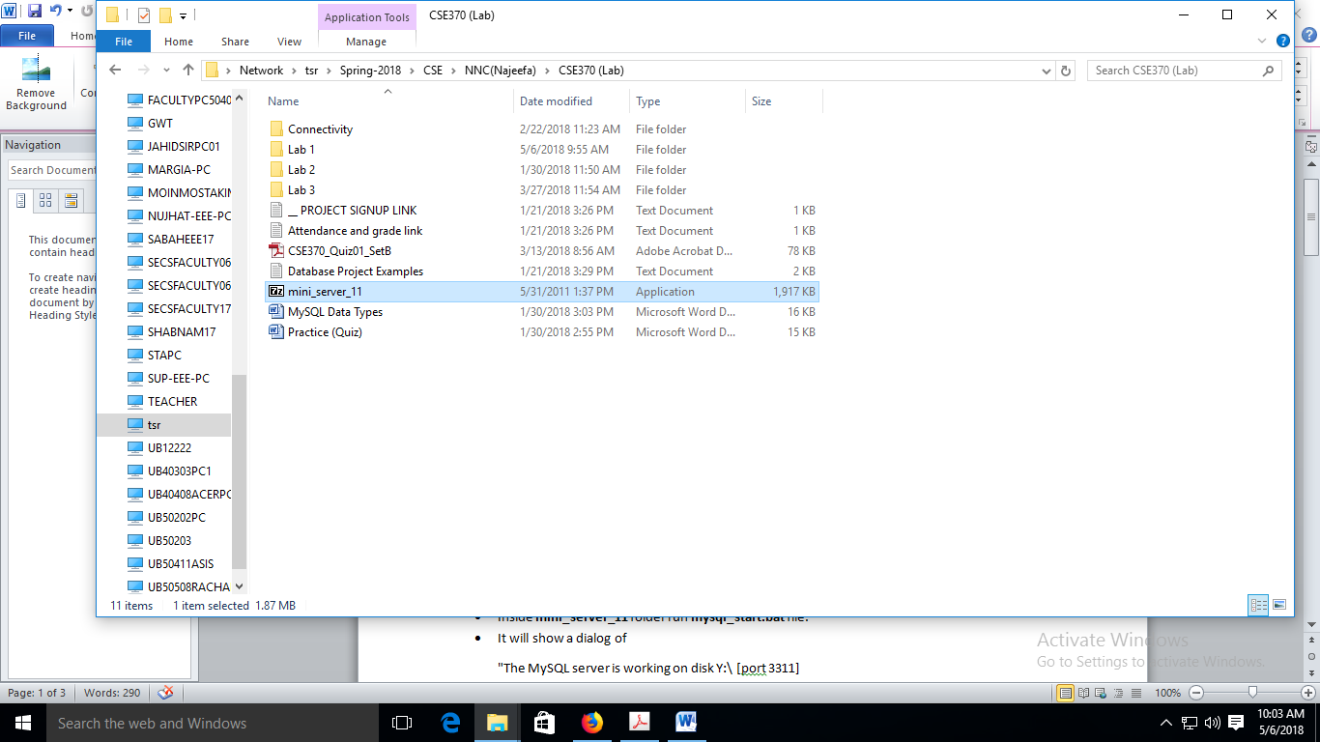

**COPY**

**TO**

**DESKTOP**

**Step 2: Extract the folder on Desktop**

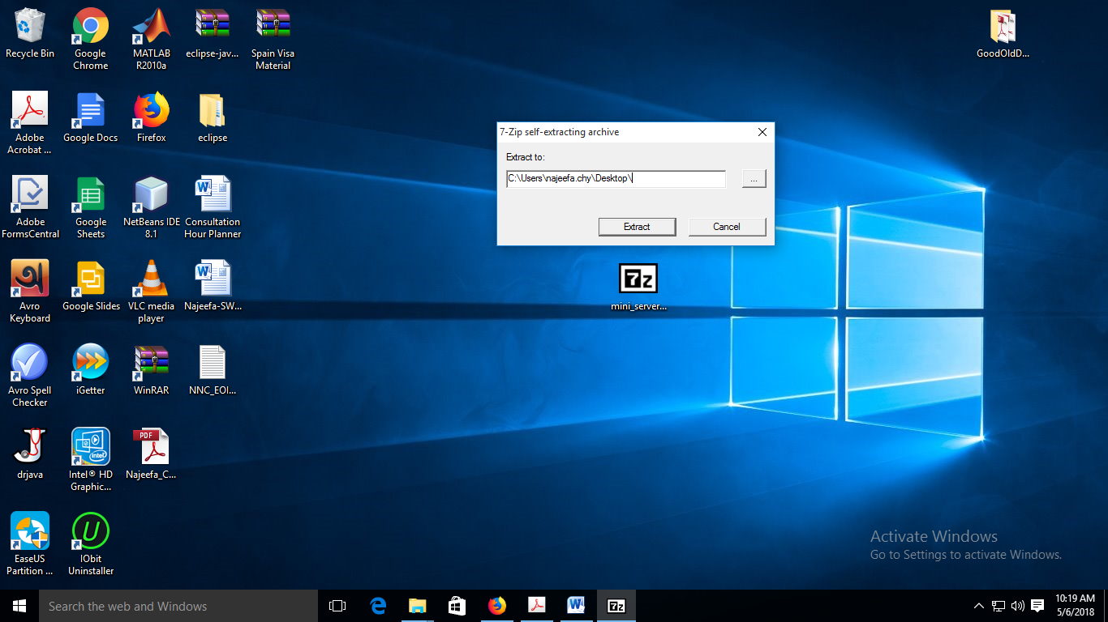

**Step 3: Go to the extracted folder and run mysql_start.bat file**

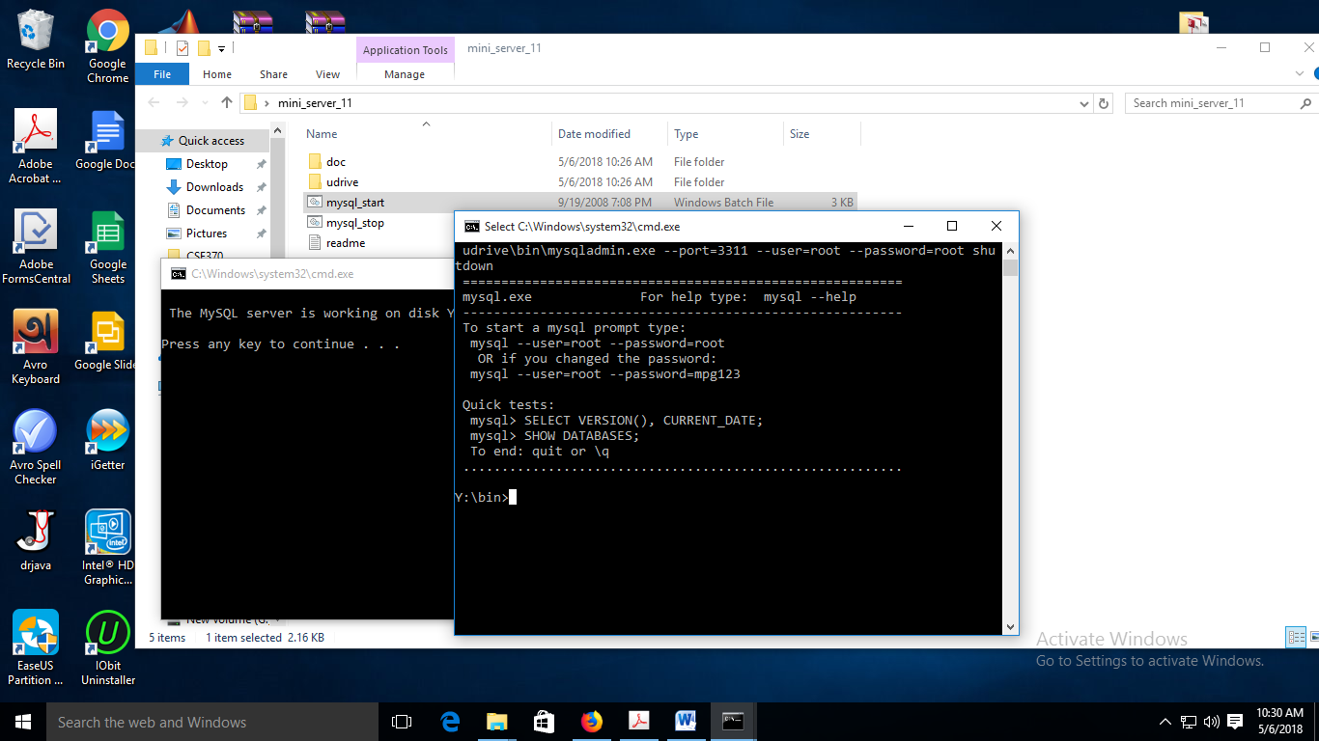

**EXTRACT**

**MINI**

**SERVER**

**This is where you will type all your commands**

**You can close this window if you want!**

**If the second window on top **does not** appear, you can run the command prompt yourself:

1. Press WIN Button + R , then type cmd
2. In the command window type **Y:**
3. Then go to bin folder by typing **cd bin**
4. It is supposed to show: **"Y:\bin>"**

**Step 4: Connect to the mysql server**

Username is root

Type: mysql -u root -p

It will ask for password and provide **root** as password.

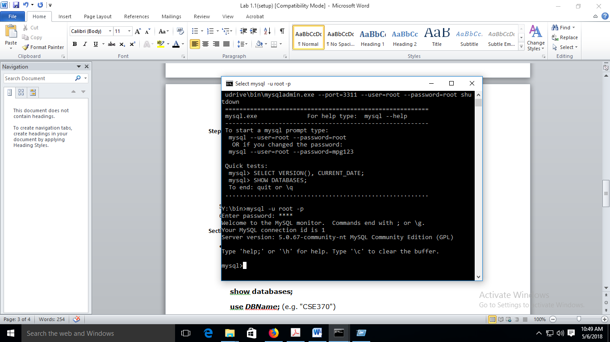

**FYI: Mini Server is a portable, mini server for practicing MySQL commands, No need to install, just extract and start working. However, for creating projects or connecting mysql with other programming languages you will need to install a real server!**

Before entering any new mysql command, make sure this prompt is there on the left.

**Step 5: CONGRATULATIONS! Your mini server has been setup and is ready to run any mysql command. Go to Part B. (Step 6 and 7 are for after you are done with part B).**

**Step 6: After your work is done, close all windows and run mysql_stop.bat file and follow instruction on the new command window.**

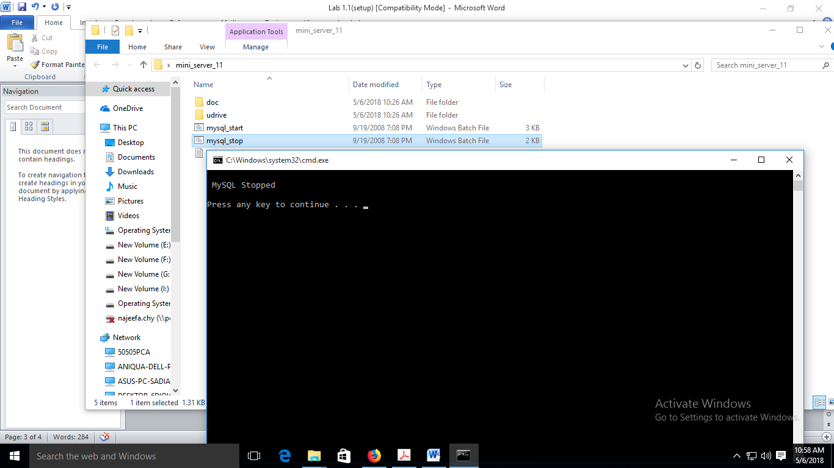

**Step 7: If you want to take your database home for later work, then go to mini_server_11>udrive>data and copy the folder with the same name as the database YOU created.**

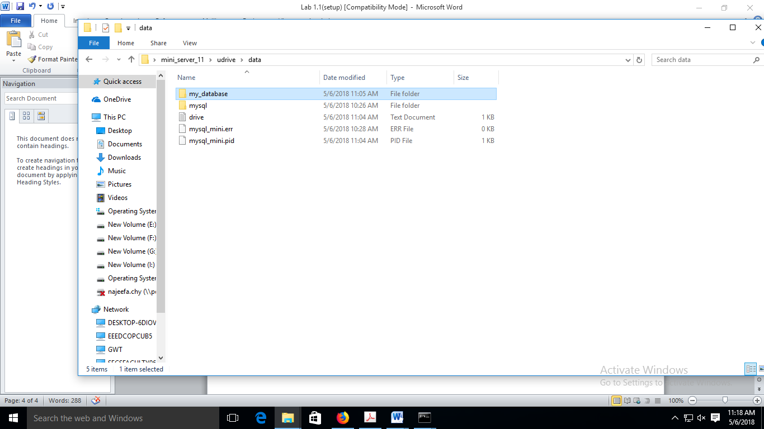

**FYI: Step 1 and 2 needs to be done every time you sit on a different PC, Steps 3 and 4 must be done before every lab.**

**Part-B  
An Introduction to MySQL Queries**

1. **Topic Overview:**

Students will get introduced to MySQL queries and will test them under the database they created in Part A.

1. **Lesson Fit:**

They would have to complete Part A first.

1. **Learning Outcome:**

After this lecture, the students will be able to:

* 1. Run and Execute simple MySQL queries e.g. CREATE, INSERT, SELECT
  2. Understand how the compiler works.
  3. Answer a short quiz regarding the tasks completed in Part A and Part B.

1. **Anticipated Challenges and Possible Solutions**
   1. Students might face problem running the queries and run into various syntax errors.

**Solutions:**

* + 1. Faculty will help them individually.
    2. Students should not copy paste queries with quotation marks, instead they should type the quotes themselves.
  1. They might face problem by accidentally closing the server window without formally exiting and might not be able to login back again.

**Solutions:**

* + 1. Restarting the server from Windows Task Manager.
    2. Restarting the computer
  1. Syntax error in a query, might cause the mysql> prompt to not appear after executing the query.

**Solutions:**

* + 1. Typing one of the following may solve the problem
       1. ‘);
       2. `);
       3. `;
       4. ‘;
       5. Or log out with ctrl+c and login agian

1. **Acceptance and Evaluation**

Students will answer a few short questions at the end of this lab, where their observation skills will be evaluated. Teachers will check that they have finished all tasks.

**Activity List for Part B**

* **All commands are shown in the red boxes .**
* **In the green box write the response you see after entering each query. Also write the query for cases where you had to make changes.**
* **The part of query in bold italic are variables, the rest are keywords. In some cases you might need to change the variables as per requirement.**
* **All new queries should be typed in command window after mysql>**
* **After completing read step 6 and 7 in part A**

A Server can have multiple databases, for example, a movie database and a car rental database. So how can you view the list of all databases?

show databases;

If you want to start a new project you should create your own database. After creating check if the new database is in the list now.

create database ***Your_DB_name*** ;

Before storing or manipulating any data, you HAVE to select the database you want to work on. All new command will take effect in selected database.

use ***Your_DB_name*** ;

All data are stored in tables. Each table will represent 1 entity, for example students_info, the column of the table will be attributes of the students(e.g. student_id, name, department, cgpa, grad_date) and each row will have information about 1 single student. Each attribute has a pre-defined data type such as int, char etc.

create table ***Lab_grades***

(

***student_id*** char(4),

***name*** varchar(30),

***major*** char(3),

***section*** char(1),

***days_present*** int,

***project_marks*** double,

***cgpa*** decimal(3,2),

***submission_date*** date

);

show tables;

You can have many tables in database, e.g student_info, teacher_info, course_info etc. So how to vie the list of all tables?

You might want to check the structure of a table e.g. what columns are there, what are the data types etc.

describe ***Your_tabele_name;***

|  |  |  |  |  |  |  |  |
| --- | --- | --- | --- | --- | --- | --- | --- |
| **Std_ID** | **Name** | **Major** | **section** | **Days_present** | **Project_marks** | **CGPA** | **Submission_date** |
| s001 | Abir | CS | 1 | 10 | 18.5 | 3.91 | 2018-09-15 |
| s019 | Naima | CSE | 2 | 12 | 20 | 3.7 | 2018-08-14 |
| s002 | Nafis | CSE | 1 | 12 | 20 | 3.86 | 2018-08-15 |
| s003 | Tasneem | CS | 1 | 8 | 18 | 3.57 | 2018-09-18 |
| s004 | Nahid | ECE | 2 | 7 | 16.5 | 3.25 | 2018-08-20 |
| s005 | Arafat | CS | 2 | 11 | 20 | 4.0 | 2018-09-13 |
| s006 | Tasneem | CSE | 1 | 12 | 17.5 | 3.7 | 2018-08-15 |
| s007 | Muhtadi | ECE | 1 | 10 | 19 | 3.67 | 2018-09-16 |
| S008 | Farhana | CSE | 2 | 6 | 15 | 2.67 | 2018-08-16 |

Insert into ***Your_table_name (std_id,name,major, section, days_present,project_marks,cgpa,submission_date)*** values (‘s001’,’Abir’,’CS’,’1’,10, 18.5, 3.91,’2018-09-15’);

Now you want to insert the data above in the table you created. There are two commands: a long version and a shorter one! Insert all the data above in the table.

Insert into ***Your_table_name*** values (‘s001’,’Abir’,’CS’,’1’, 10, 18.5, 3.91,’2018-09-15’);

So now you want to view all the data you inserted? For that we will use the select query. More on that later!

Select * from ***Your_table_name*** ;

1. **Activity Detail for both Part A and Part B**
   1. **Hour: 1  
      Discussion:** Discuss the basics of Database Systems and what are the outcomes and expectations of this lab as a whole throughout the semester. **Problem Task:**
      1. Refer to Lab Activity for Part A
   2. **Hour: 2**

**Discussion:** Discuss the basic MySQL queries such as CREATE, INSERT, UPDATE, DELETE along with their issues.

**Problem Task:**

* + 1. Refer to Lab Activity for Part B
  1. **Hour: 3**

**Discussion:** Ask students to complete the quiz (Sample attached below) and discuss the answers.

**Problem Task:**

* + 1. Refer to Sample Quiz. The purpose of the quiz is to verify they understood and noticed the small details.

1. **Home tasks**
   1. Home tasks will be to recreate the tasks done in this lab again so that they are prepared for Lab 02.

**Sample Quiz for Lab 01 (Sample Quiz)**

**Time to test your observation and deduction skills!**

1. Which keyword or symbol in an SQL query lets the server know that a command/query has ended?
2. What is the main difference between the two insert commands?
3. What is the purpose of the * in the select query?
4. How do you think you can view some selective information of all students, e.g. only name and cgpa?
5. If I write the queries in all upper case or if I mix upper and lower cases, what will happen?
6. In the create table query, the line grad_date date is a little bit different syntactically than the previous lines. What is the difference and why?
7. In the Insert command, only one value does not have a quotation mark. Which one and why?
8. What does decimal(3,2) mean in the create query and what is the highest value you can store in this case?